

A new Accounting Software Development for Southern Cross Insurance
- Introduction
In today’s age, software engineering plays a huge part in the success of Southern Cross. But what is Software Engineering? Software engineering can be defined as applying structured engineering principles to the development of software. It relies on systematic and disciplined methods for the development, operation, and maintenance of software (Senigaglia et al., 2021). One of the most used software engineering methodology is Agile. Agile is an approach characterized by flexibility, adaptation, and a human-centric focus, developed as a response to more formal, traditional development methods (Hadar & Sherman, 2012). It is a set of practices created by experienced practitioners and is also known as change-driven development. The practices were formalized in 2001 with the creation of the Agile Manifesto (Norrgren & Jacobsen, 2008).
In the insurance sector, software engineering focuses on applying systematic and disciplined methods to the development, operation, and maintenance of software tailored to the specific needs of the insurance industry (Senigaglia et al., 2021). This includes systems for policy administration, underwriting, claims processing, and customer relations management (Shekhar, 2021). The utilization of Agile methodologies in software development within the insurance industry represents a critical shift away from traditional, sequential approaches (like the waterfall model) toward models that emphasize speed, adaptability, and customer focus (Goyal, 2025).
Agile methodologies are critically important as agile methods offer flexibility and adaptability in response to constantly changing environmental forces and customer requirements (Goyal, 2025). Unlike the rigid, linear nature of the traditional Waterfall Model, Agile views requirements as evolving, prioritizing responding to change over following a fixed plan. Agile also accelerates the delivery cycle, which is essential for organizational software development projects aiming for the fastest delivery (Ngqame et al., 2024). For insurance companies, the insurance industry faces consistent change due to evolving customer demands, technological advancements, and shifts in legal frameworks. Agile promotes flexibility and adaptability in responding to these pressures, unlike the linear waterfall model which struggles in a fast-changing environment (Goyal, 2025).
Southern Cross, leader in providing health insurance to New Zealanders. Southern Cross provides various services such as travel insurance, pet insurance, health insurance, life insurance, and healthcare and hospitals (Southern Cross Travel Insurance - Compare, Quote, Buy Online | SCTI NZ, n.d.).
This report will analyse how Agile methodology can be utilized in the development of a new accounting software for Southern Cross. Part two will discuss the evolution of software engineering methodologies and how the software engineering methodologies are utilized by insurance companies today. Part three will discuss in more details the development of an accounting software for Southern Cross. Part four will discuss how the Agile hybrid approach will be implemented in the new accounting software for Southern Cross. Part five will close with summary and conclusion.
- Evolution of Agile Development
For insurance companies, software engineering has gone a long way.
In 1940s, the development of programming language started with the first generation of languages. These l used machine code, which consists of either 0 or 1, also known as binary numbers. They executed quickly but was highly prone to errors (O’Regan, 2012). In 1950s, assembly language was introduced, using clearer instructions translated by assemblers into machine code (Nerlove, 2004). This sparked a continuous innovation towards a more readable and developer-friendly programming languages.
In 1968, the NATO conference that took place in Garmisch-Partenkirchen, Germany became widely regarded as the moment the idea of software engineering gained formal recognition (Randell, 1979). It was organized in response to escalating challenges in building large systems, known as the “Software Crisis” (Randell, 1998). The event functioned as a collaborative working forum rather than a typical paper-driven meeting. Three groups explored issues in software Design, Production, and Service (Galler, 1969). Key insights included the need to borrow structured design principles from other engineering fields (Osterweil, 2007), the importance of defining software architecture roles to prevent chaotic system structures (Buxton & Randell, 1970), and clearer distinctions between debugging and system-level testing (Buxton & Randell, 1970).
In 1970s, software teams increasingly adopted plan-driven development approaches. These methods emphasized comprehensive upfront planning, extensive documentation, and strict procedural control (Wisidagama et al., 2023). They assumed that software systems could be fully defined in advance and behave predictably. Projects typically started by gathering and recording complete requirements (Norrgren & Jacobsen, 2008), then progressed through sequential stages where each phase delivered outputs for the next (Svensson, 2005). The intention was to reduce uncertainty and cost through meticulous planning, prioritizing reliable processes and high-quality deliverables (Moe, 2011).
Plan-driven development progresses through requirements, design, implementation, testing, and operation (Imani, 2017). Requirements are fully captured upfront (Norrgren & Jacobsen, 2008), followed by complete architectural design before coding begins (Petersen & Wohlin, 2010). Implementation produces the software, testing occurs late for formal verification (Akbar, 2013), and operation delivers and maintains the system (Norrgren & Jacobsen, 2008).
Plan-driven methods commonly include the Waterfall, V-Model, and Spiral models. Waterfall follows linear, phase-by-phase progression (Akbar, 2013). The V-Model links each design stage with a matching test activity (McHugh et al., 2013). The Spiral model differs by using iterative cycles focused on continuous risk assessment (Boehm & Turner, 2004; Svensson, 2005).
For insurance providers, sequential development slows delivery, with typical products requiring about 313 days to launch and more complex offerings, such as annuities, taking roughly 400 days to complete (Goyal, 2025).
Even before Agile, iterative ideas existed. Boehm’s 1986 Spiral model formally defined iterative development, while Takeuchi and Nonaka’s Scrum concepts introduced self-organizing teams and overlapping work in 1986 (Kneuper, 2018).
Introduced in 1991, RAD (Rapid Application Development) emerged as an early agile approach emphasizing rapid prototypes, intensive user input, and strict time-boxed development cycles (Kneuper, 2018).
Agile was formally defined in 2001 when leaders from various methods created the Agile Manifesto, outlining four key values that prioritize people, working software, collaboration, and adaptability over rigid processes and documentation (Manifesto for Agile Software Development, n.d.). This approach offers strong advantages, particularly its ability to handle rapid market and requirement changes (Norrgren & Jacobsen, 2008).
Created in 1999, Extreme Programming quickly gained adoption, stressing strong technical practices, rapid feedback, and support for small teams with shifting requirements (Akbar, 2013; Kneuper, 2018).
Scrum, a prominent Agile methodology alongside Extreme Programming, accepts the inherent unpredictability of development (Cohen et al., 2003). Work is organized into sprints, usually four weeks long, supported by structured meetings, including sprint planning, review, retrospective, backlog grooming, and daily stand-ups, to facilitate adaptability and continuous progress in response to change (Cohen et al., 2003).
Scrumban, merging Scrum and Kanban, emphasizes continuous improvement through Kaizen, particularly during stand-ups, while reducing waste and costs by applying best practices to maximize customer value (Alqudah & Razali, 2018; Patil & Neve, 2018).
Today, insurers adopt Agile frameworks like Scrum, Scrumban, and SAFe, using iterative delivery and cross-functional teams from underwriting, IT, marketing, and compliance to boost innovation, speed, and customer focus (Goyal, 2025).
Southern Cross, used Agile frameworks to support more modern ways of working, and flexible working options (Lambie, 2019).
3. Accounting Software for Southern Cross using Agile Methodology
Majority of Southern Cross’s value streams are through insurance premiums. These premiums are composed of many breakdowns. The aim is to manage the development of an accounting software which produces income balance sheet of all the policies sold. The output balance sheet will be used by the finance or accounting department.
For the development of Southern Cross’s accounting software, we can incorporate different agile frameworks to benefit from their advantages. Insurance companies must constantly evolve their products and services to gain a competitive edge and meet fast-changing customer demands. Agile practices enable firms to sense environmental changes and respond readily to them (Singh et al., 2024). Scrum is impactful since the core idea involves constant adaptation and continuous improvement. The most used ceremonies are planning, stand-ups (daily Scrum), and retrospectives, review, and backlog refinement, accompanied by some form of task tracking (Kruchten et al., 2019). Allianz Life Indonesia, an insurance company in Indonesia, adopted the Agile management paradigm for its software development projects within its Digital department. The company primarily follows the Scrum framework and applies practices that adhere to Agile values and principles. The motivations for adoption included faster releases, better service quality, and increased collaboration to respond quickly to market changes (Santoso & Indrajaya, 2019).
Kanban is recognized as a light-weight agile methodology based on principles from the Agile Manifesto (Viitaniemi, 2017). Scrumban, which combines the structure of Scrum sprints with the continuous flow visualization of Kanban, represents the type of hybrid approach often seen in practice (Salin & Lundgren, 2022). Scrumban specifically addresses the tension between Scrum's time-boxed iterations (sprints) and Kanban's continuous flow and visualization capabilities. Teams often integrate visualization tools, alongside standard Scrum ceremonies like daily stand-ups and retrospectives, for effective task tracking (Kruchten et al., 2019). The combination of Scrum planning/retrospectives with Kanban flow management is effective, especially in highly complex environments that resist easy division into predictable sprints (Munandar & Raharjo, 2023). ASR Insurance primarily used Scrum while many projects at ASR used the Scrum framework successfully, some teams struggled, particularly those involved in operations work or small maintenance tasks. This type of work required changes more frequently than the fixed two-week sprints typical of Scrum allowed. ASR adopted the Kanban technique along with its core principles, visualizing work, limiting work in progress (WIP), and managing flow to address these maintenance challenges. The adoption provided the necessary flexibility and control over immediate results that the clients needed. This move helped improve understanding and collaboration among developers working with different technologies and testers (Wang et al., 2012).
Extreme Programming (XP) is characterized by short development cycles, frequent customer feedback, and a focus on technical excellence (Cao et al., 2004). Although XP is generally regarded as highly beneficial for small and medium-sized projects, it has been purposefully adopted and tailored by large organizations within the financial services and insurance industries (Quelal et al., 2018). XP promotes continuous testing, simpler design, and frequently delivered working software over comprehensive documentation (Zuber et al., 2022). XP also promotes good design and technical excellence through practices like continuous code reviews. Developers are encouraged to continuously improve code and design, which is essential for critical systems like those managed by financial institutions that require high availability and integrity (van der Heijden et al., 2018). Pair programming, a concept integral to XP, encourages developers to collaborate closely to write and review code simultaneously, fostering collective code ownership and knowledge sharing within the team (Ngqame et al., 2024). For Southern Cross, using pair programming helps instill a sense of ownership within the members of the team. Continuous Integration (CI), a concept integral to XP, is a technical practice where frequently integrated software versions are automatically verified by tests and static analysis (Kowalczyk et al., 2022). This high level of technical rigor is essential in environments needing assurance, such as the highly regulated insurance industry (Garbajosa et al., 2018). For Southern Cross, using CI is important because it allows developers to test code changes early in the development process. Test Driven Development (TDD), another core XP practice, suggests incremental development by writing unit tests before writing functional code (Garbajosa et al., 2018). Programmers perceived TDD as improving code quality (making it cleaner, clearer, and simpler), enabling safer refactoring, and providing confidence to evolve and change the code due to broad test coverage (Garbajosa et al., 2018).
DevOps is an essential component of strategic Agile transformation, aiding the improvement of the development lifecycle and helping insurers gain a competitive advantage (Goyal, 2025). The core objective of implementing DevOps is to unify and accelerate development and deployment sequences, leading to improvements in the speed and quality of software processes and reports (Salvatierra Melgar et al., 2021).
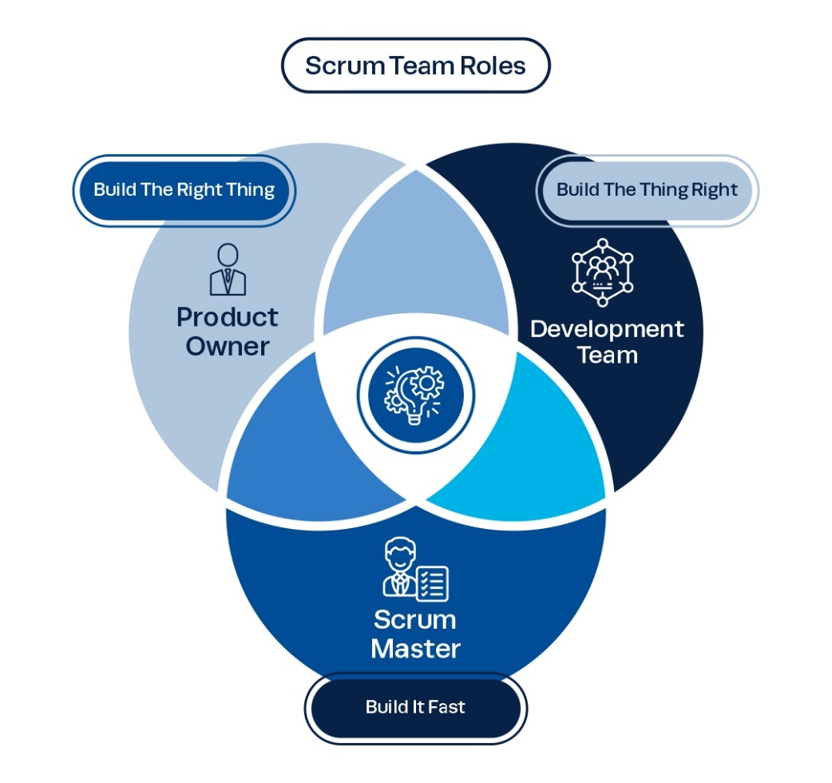
Figure 1 Scrum Roles (Institute Project Management, 2022)
The development team will be composed of 3-5 engineers, Scrum Master, and Product Owner. The Product Owner will act as the bridge between the development team and the finance team. The framework will be a hybrid approach of all the Agile framework. Scrum for the Scrum Team and ceremonies (Kruchten et al., 2019), Kanban for the visual board and the work in progress (Wang et al., 2012), XP for the TDD, pair programming, Shift-Left Testing and Continuous Integration (Garbajosa et al., 2018), And DevOps for leveraging CI/CD pipeline (Goyal, 2025).
4. Application of Scrumban for Accounting Software Development Project
For the development of Southern Cross’s Accounting Software, Scrumban will be mostly utilized, while also utilizing concepts from other frameworks such as TDD, Pair Programming, Continuous Integration, and Shift-Left Testing under Extreme Programming (XP) (Garbajosa et al., 2018), and CI/CD pipeline under DevOps (Goyal, 2025).
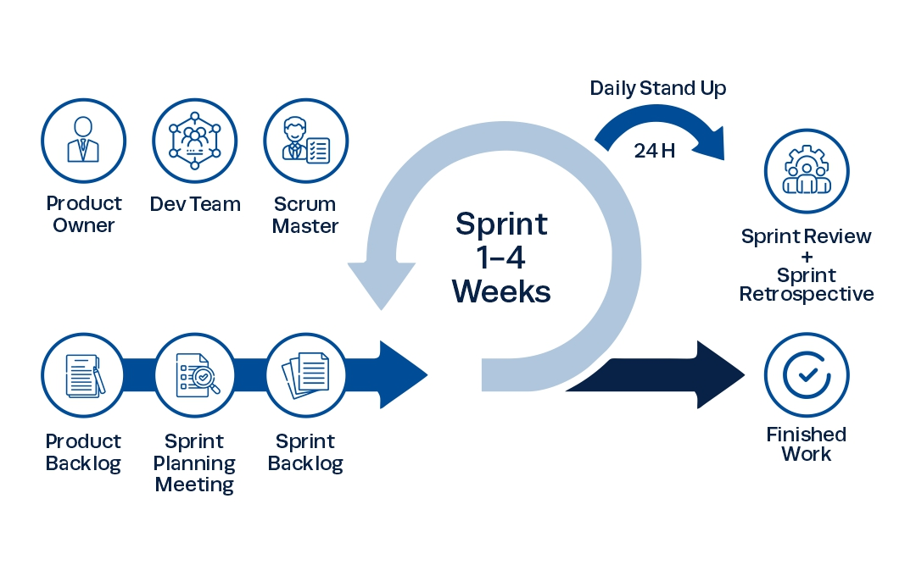
Figure 2 Scrum Framework (Institute Project Management, 2022)
Before the sprint begins (usually known as sprint 0), the Product Owner (PO), starts to gather initial requirements from stakeholders, end users, customers, clients (Patil & Neve, 2018), in this case the finance team. Since these people doesn’t really know the how to code, or the language of IT, The PO serves as an interface among developers and other stakeholders (Banijamali et al., 2016). The Product Owner uses these gathered requirements to create and maintain the Product Backlog (Alqudah & Razali, 2018). User stories are used to represent requirements and features within the Product Backlog. Customer requirements and the product vision are broken down into user stories and prioritised, often using tools like JIRA or Azure Boards (Goyal, 2025).
For the sprint planning, the scrum team determines the scope and approach for the upcoming development cycle. Scrum projects operate in short development cycles known as sprints, which typically run for a duration of between two to four weeks. The Sprint Planning ceremony occurs at the start of this cycle (Pajumaa, 2025). With the Scrum Master leading the meeting, first, the team examines the existing list of requirements and agreed-upon features. Second, the team collaboratively agrees on the specific goals for the sprint and the subsequent plan for execution. Third, the team starts creating tasks and refining the scope for implementation (Truong, 2023). Fourth, the scrum master initiates the planning poker for each user story (Cohn, 2024). And fifth, the scrum master ends the sprint planning and starts the sprint.
Planning poker is an activity within the sprint planning where the team apply relative estimates to user stories. It is a fun and engaging way for teams to apply relative estimates to planned work (Cohn, 2025). To start the planning poker, first, the scrum master and product owner will discuss one user story and describe the features to the estimators, usually the development team (Cohn, 2024). The scrum master and the product owner are not involved in estimating since they are not the ones that will do the development. Second, the estimators (development team) will vote their estimate using estimating techniques (eg. Fibonacci, tshirt sizing). Third, the estimators will show their vote and discuss their vote to the other estimators. Fourth, usually if estimators have different votes, they revote or discuss the consensus vote. Fifth, they proceed to the next user story and repeat (Cohn, 2022).
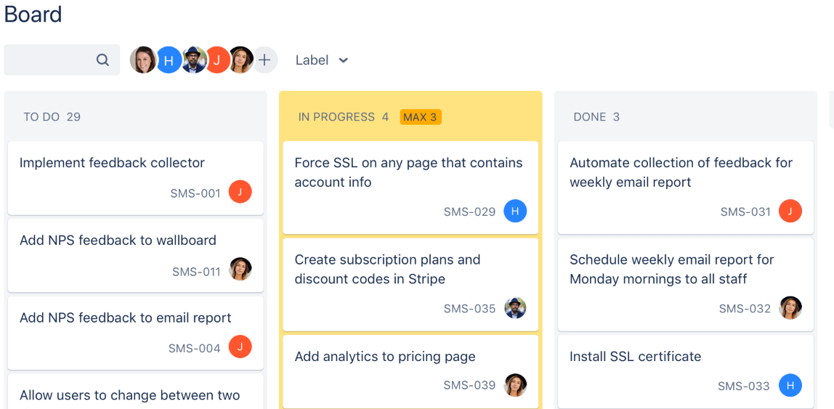
Figure 3 Kanban Board (Rehkopf, 2025)
For the daily standup, also known as daily scrum, is typically a short meeting, usually constrained to 15 minutes (Alqudah & Razali, 2018). The scrum master initiates this meeting while showing the kanban board (figure 3). In a traditional Scrum setting, team members share updates by answering core questions to assess the status against the sprint goal (Kruchten et al., 2019), typically covering the “What did I worked on yesterday?”, “What will I work on today?”, and “What are the blockers/obstacles to my tasks?” (Alqudah & Razali, 2018). For the scrum master, this meeting is helpful as it determines the pace and helps determine if the tasks are on time or delayed (Chowdhury, 2025).
For the management of in progress tasks, Kanban’s Work in Progress (WIP) Limit will be utilized as a core means of improving efficiency and flow. WIP has many objectives in each sprint, first is that it is easy is to detect constraints, or bottlenecks, in the development process (Goyal, 2025). Second is that limiting WIP helps reduce the time required to complete a feature or task (cycle time) by reducing multitasking and maintaining a continuous flow of work (Al-Baik & Miller, 2015).
Scrum of scrums, a similar meeting with daily standup, but with all the agile teams working on related products (Bradley, 2014). In our case the insurance team, accounting team, etc. This meeting is intended to manage dependencies and coordinate multiple Agile teams. Scrum of Scrums are used to keep the core teams synchronized on what is happening in other teams (Gregory et al., 2021). For Southern Cross, it will help that the accounting software team is coordinated with the insurance team because their output (policies sold) will be our input.
During the development, by implementing Work in progress limit (e.g. 3 in progress limit with 5 engineers), we can also implement XP’s Pair Programming concept (Ngqame et al., 2024). The engineers with no tasks will need to collaborate with the other engineers to complete the task faster. We will utilize XP’s Shift-Left Testing by incorporating tests early in the development phase (Gregory et al., 2021). Tools under Shift-Left Testing include automated tests such as Snyk(test for vulnerabilities, exploits from hackers) (Wiklund, 2024), and SonarQube(coding rules, readability, standards) (Lenarduzzi et al., 2020), and SonarLint that can help developers with code quality and security issues as they code (linuxuserind, 2022). We will also utilize XP’s Test-Driven Development (TDD). TDD encourages developers to create testable classes and generally improves the overall class design. It results in cleaner, simpler, and more readable source code (Garbajosa et al., 2018).
The Sprint Review meeting takes place at the end of each development cycle. The development team physically demonstrates the work that has been successfully completed during the iteration (Kruchten et al., 2019). All project stakeholders attend to provide feedback on the demonstrated features. This customer feedback is crucial as it increases the overall quality of the sprint and ensures that the output aligns with customer preferences (Alqudah & Razali, 2018). For Southern Cross, all the tasks that was finished will be demonstrated to the finance team, insurance team, and other stakeholders.
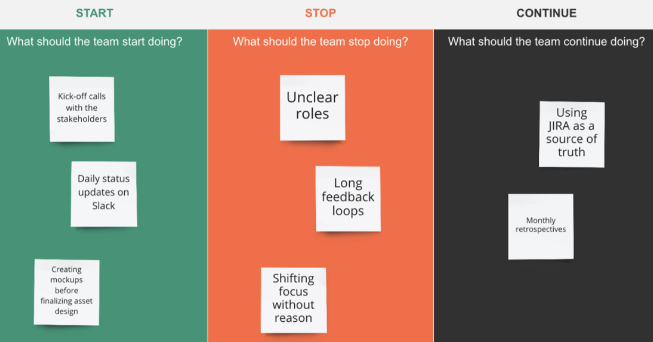
Figure 4 Sprint Retrospective Board (EasyRetro Team, 2025)
The sprint retrospective is also a meeting that takes place at the end of the sprint. It serves as a structured method for promoting discussion about issues faced and determining how these issues can be addressed in future sprints. This leads to the creation of formal actions decided upon by the teams (Alqudah & Razali, 2018). The team usually discuss “What went well?”, “What did not go well?”, and “What should we do to improve?” (Garbajosa et al., 2018).
In Delivery, usually after every sprint or by schedule, we can utilize DevOps’s Continuous Integration and Continuous Deployment (CI/CD). CI/CD tools enable software developers to provide frequent system updates, leading to enhanced performance and shorter interruption times. This automation drastically reduces manual effort and ensures faster, more reliable delivery cycles (Goyal, 2025).
5. Conclusion
In the perspective of the manager, the use of Scrumban in the development of Southern Cross’s new accounting software demonstrates how it can boost efficiency, adaptability, quality, and speed. The hybrid Scrumban model enables rapid feedback, continuous improvement and stakeholder collaboration. By integrating XP concepts such as TDD, pair programming, and shift-left testing, the new accounting software is tested to be reliable, secure, and high quality. By also integrating DevOps concept of CI/CD, we can support faster and more consistent deployments.
6. References
Akbar, R. I. (2013). Comparison Between Agile Methodology And Plan Driven As Method For ERP Development. Sisfotenika, 3(1), 11–20.
Al-Baik, O., & Miller, J. (2015). The kanban approach, between agility and leanness: A systematic review. Empirical Software Engineering, 20(6), 1861–1897.
Alqudah, M., & Razali, R. (2018). An empirical study of Scrumban formation based on the selection of scrum and Kanban practices. International Journal of Advanced Science, Engineering and Information Technology, 8(6), 2315–2322.
Banijamali, A., Dawadi, R., Ahmad, M. O., Similä, J., Oivo, M., & Liukkunen, K. (2016). Empirical investigation of Scrumban in global software development. International Conference on Model-Driven Engineering and Software Development, 229–248. https://link.springer.com/book/10.1007/978-3-319-39612-9
Boehm, B., & Turner, R. (2004). Balancing agility and discipline: Evaluating and integrating agile and plan-driven methods. 718–719.
Bradley, C. (2014, January 29). Resurrecting the Much-Maligned Scrum of Scrums. https://www.scrum.org/resources/blog/resurrecting-much-maligned-scrum-scrums
Buxton, J. N., & Randell, B. (1970). Software engineering techniques: Report on a conference sponsored by the NATO Science Committee, Rome, Italy, 27th to 31st October 1969 (J. N. Buxton & B. Randell, Eds.). NATO Science Committee.
Cao, L., Mohan, K., Xu, P., & Ramesh, B. (2004). How extreme does extreme programming have to be? Adapting XP practices to large-scale projects. 37th Annual Hawaii International Conference on System Sciences, 2004. Proceedings of The, 10-[pp]. [URL if available]
Chowdhury, W. A. (2025). Agile in Healthcare: Streamlining Medicare and Medicaid Claims Processing While Ensuring HIPAA Compliance. International Journal of Medical Science and Public Health Research, 6(05), 06–11. https://doi.org/10.37547/ijmsphr/Volume06Issue05-02
Cohen, D., Lindvall, M., & Costa, P. (2003). Agile software development (DACS State-of-the-Art Report, Vol. 11, Issue 5, pp. 1–57). Fraunhofer Center for Experimental Software Engineering Maryland and The University of Maryland.
Cohn, M. (2022, May 19). 3 Roles That Need to Be Involved in Agile Estimating with Planning Poker. https://www.mountaingoatsoftware.com/blog/3-roles-that-need-to-be-involved-in-agile-estimating-with-planning-poker
Cohn, M. (2024, June 25). Why the Fibonacci Sequence Works Well for Estimating. https://www.mountaingoatsoftware.com/blog/why-the-fibonacci-sequence-works-well-for-estimating
Cohn, M. (2025, September 4). Planning Poker: An Agile Estimating and Planning Technique. https://www.mountaingoatsoftware.com/agile/planning-poker
EasyRetro Team. (2025, December 8). Sprint Retrospective Examples For Scrum. https://easyretro.io/sprint-retrospective/sprint-retrospective-examples/
Galler, B. A. (1969). ACM president’s letter: NATO and software engineering? Communications of the ACM, 12(6), 301.
Garbajosa, J., Wang, X., & Aguiar, A. (Eds.). (2018). Agile Processes in Software Engineering and Extreme Programming: 19th International Conference, XP 2018, Porto, Portugal, May 21–25, 2018, Proceedings. Springer Nature.
Goyal, R. (2025). The role of agile methodologies in transforming insurance product development lifecycles. IJLRP-International Journal of Leading Research Publication, 6(4).
Gregory, P., Lassenius, C., Wang, X., & Kruchten, P. (2021). Agile Processes in Software Engineering and Extreme Programming: 22nd International Conference on Agile Software Development, XP 2021, Virtual Event, June 14-18, 2021, Proceedings. 211.
Hadar, I., & Sherman, S. (2012). Agile vs. Plan-Driven Perceptions of Software Architecture. 50–55.
Imani, T. (2017). Does a Hybrid Approach of Agile and Plan-Driven Methods Work Better for IT System Development Projects? International Journal of Engineering Research and Applications, 07, 39–46. https://doi.org/10.9790/9622-0703043946
Institute Project Management. (2022, February 18). Scrum: The Ultimate Guide. https://instituteprojectmanagement.com/blog/understanding-scrum/
Kneuper, R. (2018). Software processes and life cycle models: An introduction to modelling, using and managing agile, plan-driven and hybrid processes. Springer Nature Switzerland.
Kowalczyk, M., Marcinkowski, B., & Przybyłek, A. (2022). Scaled agile framework. Dealing with software process‐related challenges of a financial group with the action research approach. Journal of Software: Evolution and Process, 34(6), e2455.
Kruchten, P., Fraser, S., & Coallier, F. (2019). Agile Processes in Software Engineering and Extreme Programming: 20th International Conference, XP 2019, Montréal, QC, Canada, May 21–25, 2019, Proceedings (P. Kruchten, S. Fraser, & F. Coallier, Eds.; Vol. 355, p. 261). Springer Nature.
Lambie, D. (2019). Southern Cross – creating the healthiest workplace in New Zealand – TwentyTwo. https://twentytwo.co.nz/southern-cross-creating-the-healthiest-workplace-in-new-zealand/
Lenarduzzi, V., Lomio, F., Huttunen, H., & Taibi, D. (2020). Are SonarQube rules inducing bugs? 2020 IEEE 27th International Conference on Software Analysis, Evolution and Reengineering (SANER), 501–511.
linuxuserind. (2022, March 24). SonarLint—VS Code Extension for Code Quality. https://linuxuserind.medium.com/sonarlint-vs-code-extension-for-code-quality-c2c5186f5680
Manifesto for Agile Software Development. (n.d.). Retrieved November 2, 2025, from https://agilemanifesto.org/
McHugh, M., Cawley, O., McCaffery, F., Richardson, I., & Wang, X. (2013). An agile V-model for medical device software development to overcome the challenges with plan-driven software development lifecycles. 12–19.
Moe, N. B. (2011). From Improving Processes to Improving Practice: Software Process Improvement in Transition from Plan-driven to Change-driven Development. Norwegian University of Science and Technology, Faculty of Information Technology, Mathematics and Electrical Engineering, Department of Computer and Information Science.
Munandar, K. Y. P., & Raharjo, T. (2023). Agile Adoption Challenges in Insurance: A Systematic Literature and Expert Review. Computer Science and Information Technologies, 4(3), 268–278. https://doi.org/10.11591/csit.v4i3.pp268-278
Nerlove, M. (2004). Programming languages: A short history for economists. Journal of Economic and Social Measurement, 29(1–3), 189–203.
Ngqame, L., Ruxwana, N., & Seaba, T. R. (2024). The current state of agile methodology utilisation in a South African insurance company. South African Journal of Information Management, 26(1), 1802. https://doi.org/10.4102/sajim.v26i1.1802
Norrgren, M., & Jacobsen, B. (2008). Agile vs. Plan-driven in safety-critical development cases: A clash of principles. Lund University, Department of Informatics.
O’Regan, G. (2012). History of programming languages. In A Brief History of Computing (pp. 121–144). Springer London.
Osterweil, L. J. (2007). A future for software engineering? 1–11.
Pajumaa, M. (2025). Large-Scale Agile Implementation in the Financial Sector: A Case Study [Master’s thesis].
Patil, S. P., & Neve, J. R. (2018). Productivity improvement of software development process through Scrumban: A practitioner’s approach. 314–318.
Petersen, K., & Wohlin, C. (2010). The effect of moving from a plan-driven to an incremental software development approach with agile practices: An industrial case study. Empirical Software Engineering, 15(6), 654–693.
Quelal, R. E., Villavicencio, M., & Mendoza, L. E. (2018). A survey of agile software development methodologies in Ecuador. 2018 13th Iberian Conference on Information Systems and Technologies (CISTI), 1–6. [URL if available]
Randell, B. (1979). Software engineering in 1968 (pp. 1–10). University of Newcastle upon Tyne, Computing Laboratory.
Randell, B. (1998). Memories of the NATO software engineering conferences. IEEE Annals of the History of Computing, 19(3), 74–76.
Rehkopf, M. (2025, December 8). What is a kanban board? https://www.atlassian.com/agile/kanban/boards
Salin, H., & Lundgren, M. (2022). Towards agile cybersecurity risk management for autonomous software engineering teams. Journal of Cybersecurity and Privacy, 2(2), 276–291.
Salvatierra Melgar, A., Vértiz Osores, J. J., Vértiz Osores, R. I., Santa María Relaiza, H. R., Acevedo Flores, J., Hilario Quispe Orihuela, V., & Rengifo Lozano, R. A. (2021). DevOps as a culture of interaction and deployment in an insurance company. Turkish Journal of Computer and Mathematics Education, 12(4), 1701–1708.
Santoso, E., & Indrajaya, A. N. (2019). Discovering adoption of agile management paradigm in software development at PT. Asuransi Allianz Life Indonesia. South East Asia Journal of Contemporary Business, 19(2), 1–19.
Senigaglia, R., Irti, C., & Bernes, A. (Eds.). (2021). Privacy and Data Protection in Software Services. Springer Nature.
Shekhar, P. C. (2021). Next-Gen Test Automation in Life Insurance: Self-Healing Frameworks. International Journal of Scientific Research in Engineering and Management (IJSREM), 05(07).
Singh, N., Panigrahi, R., Panigrahi, R. R., & Shrivastava, A. K. (2024). An Integrated Total Interpretive Structural Modeling and MICMAC Model for Uncovering Enterprise Agility Barriers in the Insurance Industry. Decision Analytics Journal, 10, 100421–100421.
Southern Cross Travel Insurance—Compare, Quote, Buy Online | SCTI NZ. (n.d.). Retrieved September 13, 2025, from https://insure.scti.co.nz/
Svensson, H. (2005). Developing support for agile and plan-driven methods. Royal Institute of Technology, Department of Computer and Systems Sciences.
Truong, H. (2023). Agile Methodology Approaches European Banks. LAB University of Applied Sciences.
van der Heijden, A., Broasca, C., & Serebrenik, A. (2018). An empirical perspective on security challenges in large-scale agile software development. Proceedings of the 12th ACM/IEEE International Symposium on Empirical Software Engineering and Measurement, 1–4. [URL if available]
Viitaniemi, M. (2017). Privacy by design in agile software development [Tampere University of Technology]. [Add URL if available]
Wang, X., Conboy, K., & Cawley, O. (2012). “Leagile” software development: An experience report analysis of the application of lean approaches in agile software development. Journal of Systems and Software, 85(6), 1287–1299.
Wiklund, M. (2024). Comparative analysis and development of security tools for vulnerability detection: Exploring the complexity of developing robust security solutions.
Wisidagama, N. S., Karunarathne, M. L., Paranagama, P. D. C. J., Rathnayake, R. M. D. K. N., & Lankasena, B. N. S. (2023). A Comprehensive Study on Software Evolution in Plan Driven and Agile Methodologies.
Zuber, N., Gogoll, J., Kacianka, S., Pretschner, A., & Nida-Rümelin, J. (2022). Empowered and embedded: Ethics and agile processes. Humanities and Social Sciences Communications, 9(1), 1–13.

